Query a list of CITY and STATE from the STATION table.

Input Format

The STATION table is described as follows :

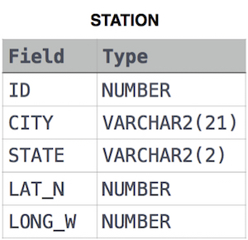

Solution:

SELECT CITY,STATE

FROM STATION;